|  |  |  |  |
| --- | --- | --- | --- |
| **Name of Student: Pushkar Sane** | | | |
| **Roll Number: 45** | | **Lab Assignment Number: 4** | |
| **Title of Lab Assignment: Build a JSP web application using standard actions, custom tags and JSTL Tags.** | | | |
| **DOP:**  **26-09-2023** | | **DOS: 28-09-2023** | |
| **CO Mapped:**  **CO2** | **PO Mapped:**  **PO1, PO2, PO3, PO11,**  **PSO1** | | **Signature:** |

**Practical 4**

**Aim:** Build a JSP web application using standard actions, custom tags and JSTL Tags.

1. To design a form and use of JSP Scripting Element and JSP Directive. Display Grade of a student by accepting marks in five subjects.
2. Write a program to design a simple web-based interface to a currency converter application. The interface should consist of a title, suitable instructions, and a form for entering the amount to be converted and an optional currency rate. Use text fields for entering the amount and rate.
3. Design loan calculator using JSP which accepts Period of Time (in years) andPrincipal Loan Amount. Display the payment amount for each loan and then list the loan balance and interest paid for each payment over the term of the loan for the following time period and interest rate:
   1. 1 to 7 years at 5.35%
   2. 8 to 15 year at 5.5%
   3. 16 to 30 year at 5.75%
4. Write a program using JSP that displays a webpage consisting of Application Form for change of Study Center which can be filled by any student who wants to change his/ her study center. Make necessary assumptions.
5. To design a form and use of JSP Scripting Element and JSP Directive. Display Grade of a student by accepting marks in five subjects.

**Code:**

**Result.jsp**

<!DOCTYPE html>

<html>

<head>

<title>Result</title>

</head>

<body>

<center>

<h1>Student marks</h1>

<form action="marks.jsp" method="get">

Enter Marks in Java: <input type="number" oninput="if(this.value > 100) this.value = 100;" name="Java"> <br><br>

Enter UXDD Marks: <input type="number" oninput="if(this.value > 100) this.value = 100;" name="UXDD"><br><br>

Enter DWM Marks: <input type="number" oninput="if(this.value > 100) this.value = 100;" name="DWM"><br><br>

Enter PPL Marks: <input type="number" oninput="if(this.value > 100) this.value = 100;" name="PPL"><br><br>

Enter Project Marks: <input type="number" oninput="if(this.value > 100) this.value = 100;" name="pro"><br><br>

<input type="submit">

</form>

</center>

</body>

</html>

**Marks.jsp**

<%@page contentType="text/html" pageEncoding="UTF-8"%>

<!DOCTYPE html>

<html>

<head>

<meta http-equiv="Content-Type" content="text/html; charset=UTF-8">

<title>JSP Page</title>

</head>

<body>

<%

int java = Integer.parseInt(request.getParameter("Java"));

int UXDD = Integer.parseInt(request.getParameter("UXDD"));

int DWM = Integer.parseInt(request.getParameter("DWM"));

int PPL = Integer.parseInt(request.getParameter("PPL"));

int Project = Integer.parseInt(request.getParameter("pro"));

int c = java + UXDD + DWM + PPL + Project;

double avg=c/5;

if(avg > 90 ){

out.println("Congratulations, your grade is A");

}else if (avg >= 80) {

out.println("Congratulations, your grade is B");

} else if (avg >= 70) {

out.println("Congratulations, your grade is C");

} else if (avg >= 60) {

out.println("Congratulations, your grade is D");

} else if (avg >= 35) {

out.println("Congratulations, your grade is E");

} else {

out.println("You have failed to clear the exam");

}

%>

</body>

</html>

**Output:**

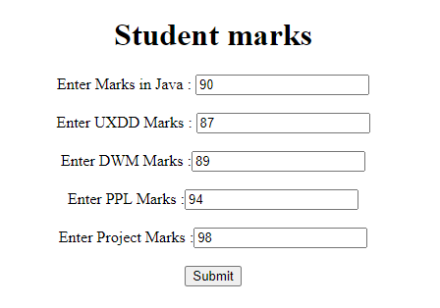



1. Write a program to design a simple web-based interface to a currency converter application. The interface should consist of a title, suitable instructions, and a form for entering the amount to be converted and an optional currency rate. Use text fields for entering the amount and rate.

**Code:**

**currency.jsp**

<!DOCTYPE html>

<html>

<head>

<title>Currency Converter</title>

</head>

<body>

<h1>Currency Converter</h1>

<p>Enter the amount to be converted and select the currencies:</p>

<form action="convert.jsp" method="post">

<label for="amount">Amount:</label>

<input type="text" id="amount" name="amount" required><br><br>

<label for="fromCurrency">From Currency:</label>

<select id="fromCurrency" name="fromCurrency">

<option value="INR">INR</option>

<option value="USD">USD</option>

<option value="EUR">EUR</option>

<option value="GBP">GBP</option>

</select><br><br>

<label for="toCurrency">To Currency:</label>

<select id="toCurrency" name="toCurrency">

<option value="INR">INR</option>

<option value="USD">USD</option>

<option value="EUR">EUR</option>

<option value="GBP">GBP</option>

</select><br><br>

<input type="submit" value="Convert">

</form>

</body>

</html>

**converter.jsp**

<%@ page language="java" contentType="text/html; charset=UTF-8" pageEncoding="UTF-8" %>

<html>

<head>

<title>Currency Conversion Result</title>

</head>

<body>

<h1>Currency Conversion Result</h1>

<%

double amount = Double.parseDouble(request.getParameter("amount"));

String fromCurrency = request.getParameter("fromCurrency");

String toCurrency = request.getParameter("toCurrency");

double rate = 0.0;

if (fromCurrency.equals("USD") && toCurrency.equals("EUR")) {

rate = 83.30;

} else if (fromCurrency.equals("USD") && toCurrency.equals("GBP")) {

rate = 0.73;

} else if (fromCurrency.equals("USD") && toCurrency.equals("INR")) {

rate = 83.03;

} else if (fromCurrency.equals("EUR") && toCurrency.equals("USD")) {

rate = 1.18;

} else if (fromCurrency.equals("EUR") && toCurrency.equals("GBP")) {

rate = 0.86;

} else if (fromCurrency.equals("EUR") && toCurrency.equals("INR")) {

rate = 89.03;

} else if (fromCurrency.equals("GBP") && toCurrency.equals("USD")) {

rate = 1.37;

} else if (fromCurrency.equals("GBP") && toCurrency.equals("EUR")) {

rate = 1.17;

} else if (fromCurrency.equals("GBP") && toCurrency.equals("INR")) {

rate = 103.10;

} else if (fromCurrency.equals("INR") && toCurrency.equals("USD")) {

rate = 0.012;

} else if (fromCurrency.equals("INR") && toCurrency.equals("EUR")) {

rate = 0.011;

} else if (fromCurrency.equals("INR") && toCurrency.equals("GBP")) {

rate = 0.0097;

}

double convertedAmount = amount * rate; %>

<h2>Conversion Result:</h2>

<p><strong> Amount: </strong> <%= amount %> <%= fromCurrency %></p>

<p><strong> Converted Amount: </strong> <%= convertedAmount %>

<%= toCurrency %></p>

<p><a href="Currency_converter_index.jsp"> Back to Converter </a></p>

</body>

</html>

**Output:**

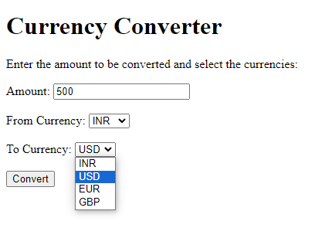

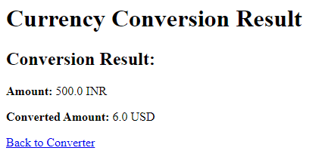

1. Design loan calculator using JSP which accepts Period of Time (in years) andPrincipal Loan Amount. Display the payment amount for each loan and then list the loan balance and interest paid for each payment over the term of the loan for the following time period and interest rate:
   1. 1 to 7 years at 5.35%
   2. 8 to 15 year at 5.5%
   3. 16 to 30 year at 5.75%

**Code:**

**loan_index.jsp**

<%@ page language="java" contentType="text/html; charset=UTF-8" pageEncoding="UTF-8"%>

<!DOCTYPE html>

<html>

<head>

<meta charset="UTF-8">

<title>Loan Calculator</title>

</head>

<body>

<Center>

<h1>Loan Calculator</h1>

<form action="loan_calc.jsp" method="post">

<label for="loanAmount">Principal Loan Amount:</label>

<input type="text" id="loanAmount" name="loanAmount" required><br><br>

<label for="loanPeriod">Period of Time (in years):</label>

<input type="text" id="loanPeriod" name="loanPeriod" required><br><br>

<input type="submit" value="Calculate">

</form>

</Center>

</body>

</html>

**loan_calc.jsp**

<%@ page language="java" contentType="text/html; charset=UTF-8" pageEncoding="UTF-8" %>

<%@ page import="java.text.DecimalFormat" %>

<html>

<head>

<title> Loan Calculation Result </title>

</head>

<body>

<center>

<h1>Loan Calculation Result</h1>

<%

double loanAmount = Double.parseDouble(request.getParameter("loanAmount"));

int loanPeriod = Integer.parseInt(request.getParameter("loanPeriod"));

double annualInterestRate = 0.0;

if (loanPeriod >= 1 && loanPeriod <= 7) {

annualInterestRate = 5.35;

} else if (loanPeriod >= 8 && loanPeriod <= 15) {

annualInterestRate = 5.5;

} else if (loanPeriod >= 16 && loanPeriod <= 30) {

annualInterestRate = 5.75;

}

double monthlyInterestRate = annualInterestRate / 12 / 100;

int totalPayments = loanPeriod * 12;

double monthlyPayment = (loanAmount * monthlyInterestRate) / (1 - Math.pow(1 + monthlyInterestRate, - totalPayments));

// Create a DecimalFormat object to format numbers with 2 decimal places

DecimalFormat df = new DecimalFormat("#.00");

out.println("<h2>Loan Details:</h2>");

out.println("<p>Principal Loan Amount: Rs " + df.format(loanAmount) + "</p>");

out.println("<p>Loan Period: " + loanPeriod + " years</p>");

out.println("<p>Annual Interest Rate: " + annualInterestRate + "%</p>");

out.println("<p>Monthly Payment: Rs " + df.format(monthlyPayment) + "</p>");

double remainingBalance = loanAmount;

out.println("<h2>Payment Schedule:</h2>");

out.println("<table border='1'>");

out.println("<tr><th> Payment Number </th><th> Payment Amount </th><th> Interest Paid </th><th> Principal Paid </th><th> Remaining Balance </th></tr>");

for (int i = 1; i <= totalPayments; i++) {

double interestPaid = remainingBalance * monthlyInterestRate;

double principalPaid = monthlyPayment - interestPaid;

remainingBalance -= principalPaid;

out.println("<tr><td>" + i + "</td><td>Rs" + df.format(monthlyPayment) + "</td><td>Rs" + df.format(interestPaid) + "</td><td>Rs"+ df.format(principalPaid) + "</td><td> Rs"+ df.format(remainingBalance) +"</td></tr>");

}

out.println("</table>");

%>

<p><a href="Loan_Calculator_index.jsp">Back to Loan Calculator</a></p>

</center>

</body>

</html>

**Output:**

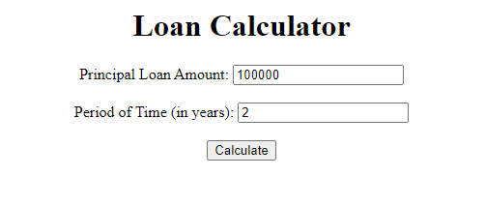

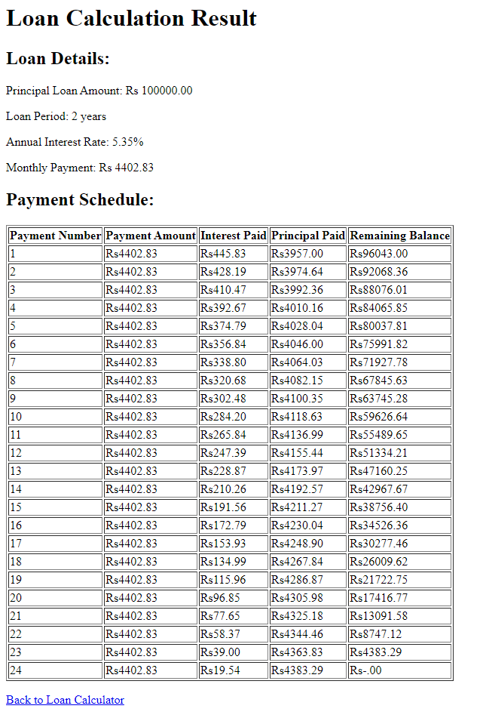

1. Write a program using JSP that displays a webpage consisting of Application form for change of Study Center which can be filled by any student who wants to change his/ her study center. Make necessary assumptions.

**Code:**

**study.jsp**

<!DOCTYPE html>

<html>

<head>

<title>Change of Study Center Application</title>

</head>

<body>

<center>

<h1>Change of Study Center Application</h1>

<form action="confirmation.jsp" method="post">

<label for="studentName">Student Name:</label>

<input type="text" id="studentName" name="studentName" required><br><br>

<label for="currentStudyCenter">Current Study Center:</label>

<input type="text" id="currentStudyCenter" name="currentStudyCenter" required><br><br>

<label for="newStudyCenter">New Study Center:</label>

<input type="text" id="newStudyCenter" name="newStudyCenter" required><br><br>

<input type="submit" value="Submit">

</form>

</center>

</body>

</html>

**confirmation.jsp**

<!DOCTYPE html>

<html>

<head>

<title> Change of Study Center Application - Confirmation </title>

</head>

<body>

<center>

<h1>Change of Study Center Application - Confirmation</h1>

<p>Dear <%= request.getParameter("studentName") %>,</p>

<p> Your request to change your study center from

<%= request.getParameter("currentStudyCenter") %> to

<%= request.getParameter("newStudyCenter") %>

has been received and is under review.</p>

<p>Thank you for your request.</p>

<p><a href="study.jsp"> Back to main page </a></p>

</center>

</body>

</html>

**Output:**

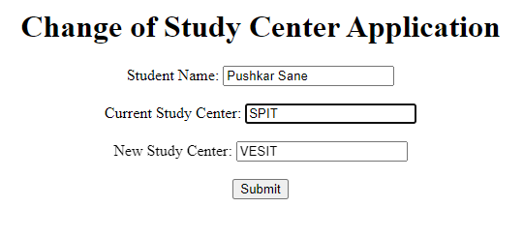

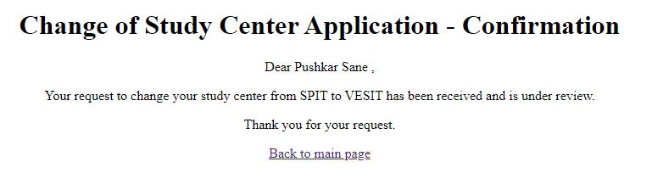

**Conclusion:** In conclusion, we learnt how to build a JSP web application using standard actions, custom tags and JSTL Tags. Incorporating standard actions, custom tags, and JSTL tags in a JSP web application enhances its functionality, readability, and maintainability. This approach streamlines development, promotes code reusability, and simplifies common tasks, resulting in more efficient and maintainable web applications.